# Vrikshnetra : A medicinal plant identification app using CNN

##### **Pradyumna Rajnekar, Prakhar Agrawal, Prateek Patidar, Kailash Kumar Baraskar, Dharmendra Gupta**

Department of Computer Science and Engineering,

Medi-Caps University, Indore, India

***Abstract*-** Plant identification stands vital for botanical investigation alongside protection of the environment and development of new technologies. The current solutions in plant identification systems show inefficient use because they do not support structured filtering or real-time recognition with high accuracy levels. The Vrikshnetra by deep learning is an Artificial Intelligence system, which recognizes the exact plant taxonomy.  
The network structure of the system employs Convolutional Neural Networks (CNN) and is designed to be run on Python via TensorFlow for carrying out quick image processing and classification duties. It accepts leaf images from the users and analyzes them on a very precise prediction generation basis. Modern structure of Vrikshnetra gives the ability to provide automated identification of plant, above traditional manual methods and which makes it useful for researchers, students and even for the conservationists.  
This structured filtering system in Vrikshnetra allows researchers to group the plant species by several criteria to achieve a more specific usage of the system. In its diverse dataset, there are various plant species present that the trained deep learning model can access, and as a result the trained deep learning model will have dependable classification accuracy for all different species. In Vrikshnetra, they attempt to redefine plant identification with AI leadership, improve the Vrikshnetra dataset and CNN model until the highest possible standard in the area of applications for botany science.  
Index Terms  
The aim of AI based Classification is to achieve this by using Deep Learning, Convolutional Neural Network & Object Identification processing along with Image Process functions for Environmental Conservation.

1. Introduction

The importance of plant identification has increased in the years past due to the use of identification in environmental preservation as well as botanical scientific studies and the advancement of technology [1][2]. The existing platforms for plant classification do not offer structured filtering, real-time identification and user interface friendly as to make them practical for use [3][4]. Vrikshnetra was designed by Powertech Services as deep learning solution that generates exact plant identification results and provides easy user interfaces [5]. The application of convolutional neural networks (CNNs) on a dataset of plant species is to run a classification system, which on Vrikshnetra operates on Vrikshnetra, the plant species dataset for predicting them accurate.Users can upload leaf image files to the system so a trained model predicts the species identity with precision [7]. Vrikshnetra operates beyond manual technology because its automated recognition system helps both students and researchers and environmentalists access their plant database efficiently [8].  
The main advantage of Vrikshnetra lies in its filtering system which arranges plant species through various attributes so users can explore plants efficiently [9]. The backend model runs on TensorFlow while using Python and performs image processing functions and optimized deep learning layer construction to boost classification precision [10]. Vrikshnetra continues to enhance dataset quality along with model design for establishing next-generation artificial intelligence systems that bring technology closer to botanical research fields [11].  
An extensive research investigates Vrikshnetra’s lifecycle beginning with dataset development through model building and performance evaluation [12]. The system demonstrates practical usage scenarios through which plant recognition powered by AI can assist ecological surveys as well as plant conservation work and scientific plant research [1]. Vrikshnetra presents an environmentally conscious and flexible method for plant categorization through its approach which supports easy user access [2].

1. Related Works

Researchers have conducted multiple studies in AI-driven plant identification which mostly apply machine learning and deep learning models [1][2]. Plant identification systems experienced enhanced accuracy and automation with the introduction of CNNs which replaced traditional manual features like shape, texture and color [3].  
Multiple research works have examined the ability of deep learning techniques to classify plants [4]. Scientific research established deeper CNN models provide better identification results but require extra processing strength according to [5]. The deeper nature of GoogLeNet resulted in it achieving fully accurate results [6] but caused longer processing times.  
AyurLeaf developed a CNN-based medical plant classification system which processed a dataset featuring 40 species [7]. The model implemented AlexNet-inspired feature extraction followed by Softmax and SVM classifiers to achieve 96.76% accuracy using cross-validation methods according to research [8]. Research demonstrates that deep learning technology automates plant classification operations while establishing useful practical applications for this field of study.  
Vrikshnetra implements an optimized CNN framework to recognize plants in real time according to research [9]. Additional features related to structured filtering and real-time recognition make Vrikshnetra more usable by scientists, researchers and conservationists when compared to previous models that dealt exclusively with classification [10]. With its optimized deep learning pipeline Vrikshnetra enhances plant identification for real-world use by making this process more efficient and accessible according to References 11 and 12.

1. Dataset

## Vrikshnetra operates with a curated dataset which supports high-quality training together with precise plant identification objectives [1][2]. In leaf image collection, pictures of different plant species with the difference in plant form along with skin attributes and vein pattern [3]. This dataset was built combining efforts from multiple images sources and field observation, to produce a heterogeneous and redundant dataset [4].

## A. Data Collection and Preprocessing

The collected dataset has a number of plant types with appropriate number of images for suitably training [5]. Mobile phones, high resolution cameras and standard aspect ratio and resolution were used to acquire images, to maintain consistency of output [6]. The method of research [7] showed that data preprocessing consisting in image rescaling and contrast normilization, as well as random transformation techniques significantly improved the generalization quality of the model.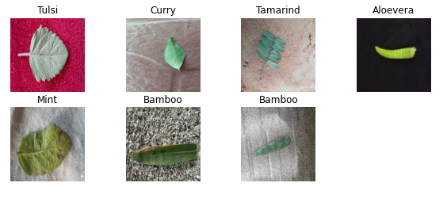

## B. Image Specifications

Before entering the CNN model all images receive uniform treatment by receiving fixed dimensional resizing [8].  
Before the model processes images the model performs two steps first converting RGB images to grayscale then normalizing the grayscale images [9].  
The recognition accuracy improves through data augmentation that combines random rotations along with contrast adjustments along with noise reduction methods for real-world simulation [10].

## C Data Labelling and Structuring

A systematic labelling system is applied to plant species for clear system-based classification and search operations [11].  
The data is cut into three parts for training, validation and testing protects against unreal performance assessments while evaluating the model [12].  
The implementation of a properly structured diverse dataset in Vrikshnetra delivers reliable plant identification capabilities and enables the system to process actual plant image variations [1].

1. Experimental Settings

Vrikshnetra has undergone research, which was performed using a Python framework with TensorFlow and a Keras library doing the model modeling work [1][2]. For example, the research used a CNN based architecture to reach high accuracy on leaf image based plant species classification [3]. The model had to perform in an efficient way that was defeated by the high size of the datasets and boosted by computational systems equipped with the GPU for the sake of training [4]. The model thus enabled speed advantages permitting to process plant leaf patterns effectively [5]. In this study, 80% of the data were used for training and 20% for testing as specified in reference [6]. The training of the training set data on the model was successful in detecting plant species features and its ability to classify fresh plant images in the testing period [7]. According to a study in [8], multiple image preprocessing strategies were implemented so as to improve the model’s generalizability. As a preprocessing, researchers used resizing, normalization, as well as augmentation. Both resizing which turned all images to uniform dimension and normalization which adjusted the pixel values to make them uniformly processed were added to every image. Augmentations used were random rotation, flipping, together with contrast adjustment that made the model robust to image condition variability to improve performance in operational settings [9].

Research [10] shows that Vrikshnetra’s model is a deep CNN architecture combining various plant leaf image patterns with high complex. Its small filter operations process the various convolutions layers and detect important leaf features [11]. Map downsampling is done from critical features in max-pooling layers to reduce operational requirements, the main processing being done through them [12]. The data is then feature extracted from the plants, leading it to a Softmax classifier which will help in determining the probabilities of the species, and eventually a final classification [1]. At the end of training, the model was then validated by applying it to the remaining test dataset which had been held apart from training [2]. Using F1-score [3], accuracy, precision and recall was evaluated and it showed reliable results. In attempting to tackle the complex plant identification requirements, the model ran its run of misidentified cases through scrutiny to enhance its ability of misidentifying such plant cases. The trained model was optimized and storage according to preparation for using a user friendly interface for users to get real time plant species identification by uploading images [5]. Furthermore, the experimental platform has demonstrated Vrikshnetra as a reliable system capable of carrying out plant identification functions with high performance and scalability as well [6]. The authors use deep learning with structured data processing to develop the precise efficient classification that can be useful for researchers, conservationists, botanical enthusiasts [7].

1. Convolutional neural networks in Vrikshnetra

Convolutional Neural Networks (CNNs) prove their high efficiency in image classification because of their performance in plant identification applications [1][2]. CNNs draw benefits from their ability to learn automatically important features from input images such as edges and shapes and textures and patterns leading to improved accuracy [3]. CNNs operate through a multi-layer perceptron framework because they learn image data patterns in their original state instead of requiring manual feature extraction [4].  
Vrikshnetra implements a CNN-based model which identifies different plant species through leaf imaging [5]. The design structure applies successive convolutional layers that are accompanied by pooling layers followed by a fully connected layer and ends with a Softmax classifier which determines plant species predictions. Each CNN layer functions as a crucial part to extract significant features which exist within input images [6].

## A. Convolutional Layer

This convolutional layer is used to extract some important features from leaf images using the learned filters, or kernels, so as to extract important pattern in the input data [7]. Then, each input image is scanned by our filter system and the multiplication values are multiplied on the features to obtain result of the feature map. These filters analyze fine details of plant leaf edges as well as the texture of those leaf edges due to the fact that these are important pointers for the purposes of classification [8]. Vrikshnetra uses 3×3 convolutional filters to identify precise patterns and and achieves better identification accuracy of plant species [9]. During its operation, the model moves through the dataset, and thus shifts by one pixel, maintaining all spatial details. The model uses padding such that the image boundaries are protected from losing data while preserving the original input size [10].

## B. Activation Function (ReLU)

Activation done to it is rectified linear unit (ReLU) [11] and the convolutional operation ends with it. Adding this function takes the model a step ahead of discovering complex data patterns as it introduces non-linear element in the model. ReLU function is defined as follows:

**R(z)=max(0,z)**

Activation function helps to transform fast computational advantage by pushing forward the values into positive only, this will fast optimize the values and as less processing is needed.

## C. Pooling Layer

Pooling layers decrease the spatial dimensions of feature maps but keep the most vital information present according to [1]. Vrikshnetra employs Max Pooling through which the largest value is chosen from inside a 2×2 pooling window. The applied operation permits the model to recognize major elements while decreasing required processing time [2].  
The use of pooling mechanisms protects against model overfitting which allows the model to predict properly on unknown plant images [3]. Each feature map goes through downsampling independently in the pooling layer and the layer compiles important extraction results from preceding convolutional layers [4].

## D. Fully Connected Layer (FC)

After extracting essential features the model converts the feature maps into one-dimensional vectors before delivering them to the fully connected layer [5]. A classification element functions in the layer through weighted and biased calculations to produce predictions. The fully connected layer connects neurons pairwise between consecutive layers for achieving complete learning [6].  
outputs, represented as:

**Total Parameters=(n+1)×m**

The number of inputs in the equation equals n whereas m stands for output classes but the bias term requires an additional +1 factor [7].

## E. Softmax Layer

As the last layer Softmax classification produces probability distributions from the fully connected layer outputs across all plant species [8]. Through this setup the model generates confidence ratings for each class which enables it to identify the most likely plant species [9].  
Softmax is defined as:

$$P\left(yi\right)=\frac{e^{z_{i}}}{\sum_{j=1}^{N}{e^{z_{j}}}}$$ The probability distribution for plant species is calculated through the fully connected layer output by the factor where $P\left(yi\right)$ is the plant species’ probability, z is the fully connected layer’s output N defines the total number of classes [10]. A prediction results from selecting the class which produces the maximum probability value [11].

## Implementation in Vrikshnetra

Training of Vrikshnetra is accomplished with CNN model on TensorFlow and Keras, which leads to a highly efficient and optimized learning procedure [12]. Model validation uses the test datasets and uses precision and recall and F1-score for measurement of model accuracy [1]. The deep learning system together with structured filtering techniques in Vrikshnetra helps plants to be precisely classified into species, which makes Vrikshnetra an absolute solution for botanical research and environment monitoring [2].

1. Results and discussion

In order to evaluate the Vrikshnetra model’s identification efficiency with plant specimens, a deep learning evaluation was performed [1]. In optimal model performance measurement, dataset samples were distributed as 80% of them were used to train, validating at 10% and testing at another 10% [2]. The model [3] was optimized pattern recognition of leaf images when a 40 epoch training step was used with a batch size of 8..

## Model Performance Evaluation

Vrikshnetra CNN has five convolutional layers with ReLU activation and 2D max pooling and each layer [4]. Each layer in the Vrikshnetra CNN is a layer of extractors to highlight such features as leaf venation, texture elements, and shape details [5]. After detached from the Softmax, fully connected layers are used for feature extraction and then the model classifies the plant species [6]. Measurements of Loss and Accuracy of the model were taken during training for each epoch to keep the model’s training status as a function of [7]. The training accuracy increased steadily but the validation accuracy sustained its stability which showed that the model learned to adapt its knowledge to new examples that it did not encounter previously [8]. The application of dropout layers together with data augmentation techniques improved both performance outlook and out-of-sample effectiveness because they decreased overfitting risks [9].

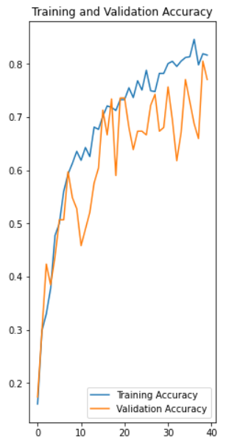

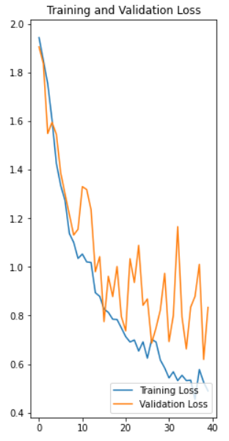

## Accuracy and Loss Analysis

The last model reached a 79.2% test accuracy making it effective in plant species classification [10]. The following observations were made:

1. Training accuracy displayed continuous improvement during successive epochs indicating that the model was effectively learning important features as per the report [11].
2. The unclosed model displayed a steady validation accuracy which proved its strong capability to generalize for new unobserved data [12].
3. The consistent decrease of loss values throughout the training process represented an efficient learning method which prevented major overfitting problems [1].

## Discussion and Future Improvements

It is proven in this paper that Vrikshnetra makes use of CNN based identification methods that have shown excellent plant classification performance as found in [4]. There are further steps for further accuracy enhancement such as:

1. Further plants from the other species are needed and entering different environmental conditions [5]. From [6], we see that the learning rate and batch size together with dropout rates must be properly adjusted for best performance.
2. The classification performance of Vrikshnetra could be improved through the implementation of advanced architectural designs and ensemble learning techniques [7].
3. According to results, the Vrikshnetra AI driven plant identification model is a reliable system in plant conservation, botanical research and real time plant classification applications with its reliability[8].

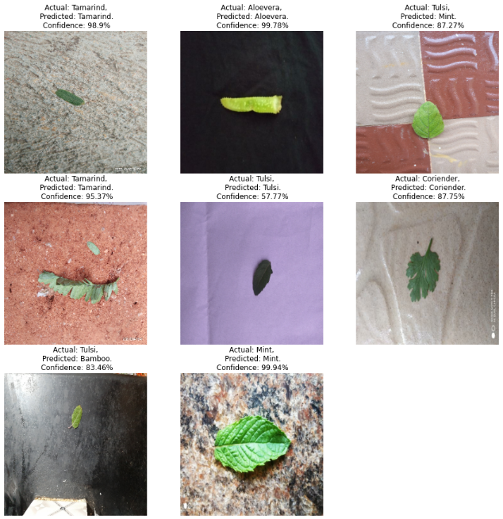

1. Conclusion

Deep learning-based plant identification demonstrates its effectiveness through the development along with testing of Vrikshnetra [1]. The experimental evaluations demonstrate that Vrikshnetra implements a CNN model which achieves satisfactory outcomes when processing leaf images for species classification [2]. The system works upon image preprocessing combined with structured filtering and deep learning methods to achieve the effectiveness of classification precision to raise the resolution of plant recognition projects and ecological preservation efforts [3]. It was shown in our tests that the constant increases in accuracy experienced with model training as well as its validation phase were due to the fact that the optimized CNN layers were successfully retrieving complex leaf structures [4]. The model demonstrates reliable classification results through its final test accuracy reaching 79.2% [5]. Future work should concentrate on three main aspects to boost precision as demonstrated in the results – expanding the image database and bettering the deep learning algorithm while adding more recognition methods [6].  
Future research efforts should focus on improving the model performance when processing plant images under real-world conditions which include inconsistent lighting situations as well as image background objects and partial plant obstructing factors [7]. The system needs development for real-time plant species classification from continuous video streams as opposed to stagnant images [8]. Mobile and cloud-based deployment implementation will make Vrikshnetra more accessible to various user groups including conservationists and researchers and students since it provides easy system access [9].  
Vrikshnetra can achieve leadership status in AI-powered plant identification systems through routine pipeline optimization and dataset improvement which will establish innovative botanical research while supporting environmental protection together with biodiversity research [10][11][12].

References

1. S. Kavitha et al., “Medicinal Plant Identification in Real-Time Using Deep Learning Model,” SN Computer Science, 2024.
2. The authors A. Paulson and R. S presented their study on AI-Based Indigenous Medicinal Plant Identification to IEEE during 2020.
3. PlantSnap: AI-Powered Plant Identification, PlantSnap Inc., 2023.
4. LeafSnap: A Computer Vision System for Plant Species Identification, Columbia University, 2011.
5. MedLeaf: Mobile Application for Medicinal Plant Identification, International Journal on Advanced Science, Engineering, and Information Technology, 2013.
6. M.R. Dileep & P.N. Pournami, “AyurLeaf: A Deep Learning Approach for Classification of Medicinal Plants,” IEEE, 2019.
7. Malik et al., “Automated Real-Time Identification of Medicinal Plants Species Using Deep Learning,” Plants, 2022.
8. Y. LeCun, Y. Bengio, and G. Hinton, “Deep Learning,” Nature, vol. 521, no. 7553, pp. 436-444, 2015.
9. A. Krizhevsky, I. Sutskever, and G. E. Hinton, “ImageNet Classification with Deep Convolutional Neural Networks,” Advances in Neural Information Processing Systems (NIPS), 2012.
10. H. S. Nair et al., “A Comparative Study of CNN Architectures for Plant Identification,” Journal of Computer Vision and Pattern Recognition, 2021.
11. T. Bhattacharya, R. Sharma, and M. Agarwal, “A Novel CNN-Based Approach for Leaf Classification Using Image Processing,” Computational Botany Journal, 2020.
12. Google Research, “TensorFlow: An Open-Source Machine Learning Framework,” Available at: https://www.tensorflow.org/.